LAHIFFE & ASSOCIATES
Public Affairs & Political Communications 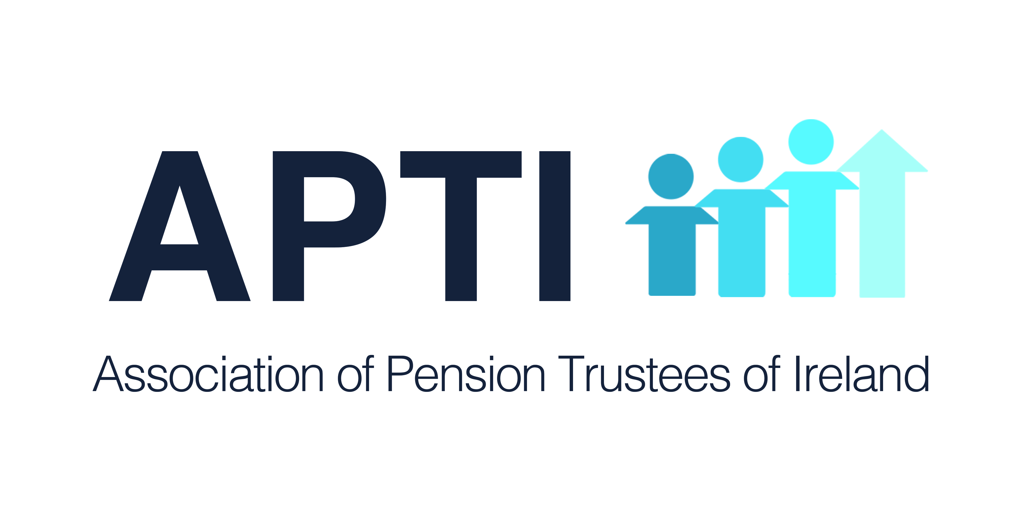
OIREACHTAS REPORT FOR APTI

December 11 - 13, 2018

PENSION ISSUES
Dail

Tuesday, December 11

No relevant business

Wednesday, December 12

Questions on Promised Legislation

Deputy Willie O'Dea: Could I ask the Taoiseach what arrangements, if any, are in place to protect the reciprocal arrangements for the receipt of State benefits between Ireland and the UK, including Northern Ireland? For example, 135,000 people in Ireland are currently in receipt of British State Pensions and approximately 70,000 are in receipt of private pensions from the UK. Many of those people are very concerned, and they need reassurance. Could the Taoiseach offer them that?

The Taoiseach: Minister Doherty has done a lot of work on this matter with her colleague in the UK. I can assure people who receive UK pensions in whole or in part, or part of a UK benefit, and vice versa, that it will continue.

Deputy Willie O'Dea: Will it be seamless?

The Taoiseach: Yes.

Written Questions

State Pension

Deputy Jan O'Sullivan asked the Minister for Employment Affairs and Social Protection if she has addressed the issue of women whose children were born before 1994 who were excluded from the Home Carer's Scheme and as a result qualify for a much reduced contributory pension in comparison to other women then took time out of the workforce to care for children; if not, her plans to address this issue in the future; and if she will make a statement on the matter.

Minister for Employment Affairs and Social Protection (Deputy Regina Doherty): A policy to introduce the TCA to pensions calculation was adopted by Government in the National Pensions Framework in 2010, as was the decision to base the entitlements of all new pensioners on this approach from around 2020. In advance of this, on January 23 this year, the Government agreed to a proposal that will allow pensioners affected by the 2012 changes in rate bands to have their pension entitlement calculated by an interim TCA which will include up to 20 years of new HomeCaring Periods. This approach is expected to significantly benefit many people, particularly women, whose work history includes an extended period of time outside the paid workplace, while raising families or in a caring role. The TCA will ensure that the totality of a person’s social insurance contributions - as opposed to the timing of them - determines their final pension outcome. The HomeCaring Periods can be claimed for any year in which they occurred - they are not limited to years since 1994.

People whose pensions were decided under the 2000-2012 rate bands were subject to a significantly more generous regime than those who qualified before or afterwards, as a yearly average of only 20 contributions per year (out of a maximum of 52) could attract a 98% pension. The effect of those changes, as it impacted upon those new pensioners since 2012, will be familiar to anyone who followed the debate on this matter over the last 6 years. If pre-2012 pensioners were also allowed avail of HomeCaring Credits, their arrangements, as a group, would continue to be significantly more generous than those of post-2012 pensioners. There would also be a very significant cost which would be expected to be of the order of several hundred millions of euro each year. This in turn could significantly impact funds for future pension increases with consequential implications for pensioner poverty.

For those with insufficient contributions to meet the requirements for a State Pension (Contributory), they may qualify for a means tested State Pension (Non-Contributory), the maximum personal rate for which is €232 (over 95% of the maximum rate of the contributory pension). This rate of payment does not include Rent Allowance, Household Benefits or Fuel Allowance. Alternatively, if their spouse has a State Pension and they have significant household means, their most beneficial payment may be an IQA, based on their personal means, and amounting up to 90% of a full contributory pension.
Thursday, December 13
No relevant business

Seanad
Tuesday, December 11
No relevant business

Wednesday, December 12
No relevant business

Thursday, December 13
No relevant business

Oireachtas Committee
Finance Committee
Superannuation and Retired Allowances (edited)
Minister of State at the Department of Public Expenditure and Reform (Deputy Patrick O'Donovan): This is a minor and somewhat technical Vote we would like to get approved by the Committee. I am here this morning to present the committee with a proposal for a net Supplementary Estimate of €1,000 in respect of Vote 12 - superannuation and retired allowances. The Supplementary Estimate in respect of this Vote will bring the 2018 Estimate for the Vote to €584.9 million gross and €366.2 million net. The Supplementary Estimate arises from higher than forecast costs for the year under the pension scheme for established civil servants. There were also balances payable to former civil servants who retired in 2009 under the incentivised scheme for early retirement.
Pensions and lump sums paid under the pension schemes for established civil servants make up just under 90% of the total gross expenditure on the superannuation and retired allowances Vote. The main driver of the annual cost is the number of established civil servants who retire in the year. It is particularly difficult to estimate the number of retirements from one year to the next for a number of reasons. These include that the majority of established civil servants may choose to retire within a five year window between the ages of 60 and 65. In addition, a number of people aged under 60 retire each year under the cost neutral early retirement scheme or on the grounds of ill-health. Each year, a number of former employees become eligible to claim a preserved pension entitlement. The average pension benefits lump sum and pension that will fall to be payable to new retirees in any given year will depend on the grades and years of service of that specific cohort of retirees.

The 2018 gross Estimate for Vote 12 was €569.9 million, based on a forecast of 1,585 retirements from the established scheme. As a general rule, for each person who retires, the once-off lump sum paid out is three times the size of the annual pension. Accordingly, increases in retirement levels have a particular effect on subhead A4, which provides for the lump sum payments to established civil servants. Subhead A4 is, therefore, a key driver of the expenditure variants on the Vote in any given year. To the end of October, €88.5 million was expended from subhead A4 compared to the original 2018 full year estimate of €94.2 million. It is now estimated the gross expenditure of the Vote for 2018 will be in the region of €584.9 million, €15 million in excess of the gross Estimate of €569.9 million as voted previously by the Oireachtas.

The Committee should also note that the level of gross Supplementary Estimate being sought will be mitigated by anticipated levels of appropriations-in-aid. The figure for appropriations-in-aid for 2018 was estimated at €203.8 million. To end October, receipts of €191.8 million have been received and with receipts with regard to the single public service pension scheme ahead of profile year to date total appropriations are now projected at €218.8 million by year end, which is €15 million more than expected. I am seeking the Committee's approval for the use of this excess to reduce the net effect of the gross Supplementary Estimate.

I am satisfied that the appropriate Supplementary Estimate of €1,000 net will confer the necessary legal authority to meet the pension entitlements of the civil servants expected to retire at the end of 2018.

Deputy Jonathan O'Brien: I am happy with the proposal.

Deputy Jack Chambers: It appears this is a procedural matter.
Amendment approved

______________________________________________
LAHIFFE & ASSOCIATES
Public Affairs & Political Communications
+353 87 256 2166
www.linkedin.com/in/franklahiffe

