LAHIFFE & ASSOCIATES
Public Affairs & Political Communications 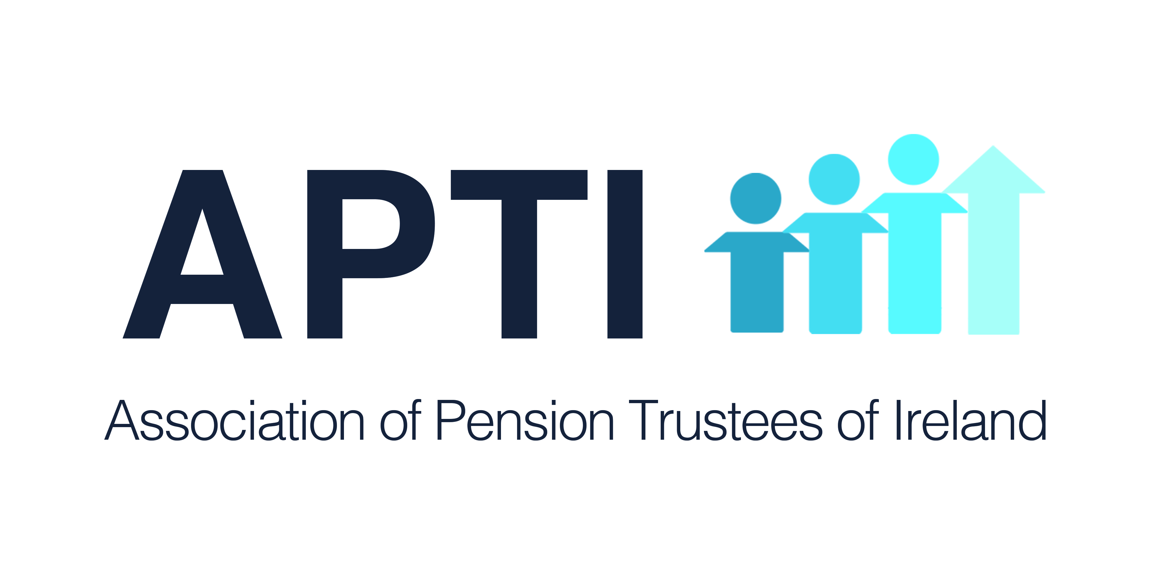
OIREACHTAS REPORT FOR APTI

January 22 - 24, 2018

PENSION ISSUES

Dail

Tuesday, January 22

Written Questions

State Pension Reform
Deputy Éamon Ó Cuív asked the Minister for Employment Affairs and Social Protection the number of pension recipients that had their cases reviewed to date under the new TCA and home caring credit scheme introduced in 2018; the number that on review have been awarded a higher payment; and if she will make a statement on the matter.
Minister for Employment Affairs and Social Protection: Since the end of September 2018, my Department has been examining the social insurance records of pensioners born on or after 1 September 1946 who were awarded State Pension (Contributory) on reduced post Budget 2012 rate bands. Information letters were issued to these pensioners explaining that my Department will contact them again to either inform them about the outcome of their review or to request further information in order to complete their review. All of the claims involved will be individually examined and reviewed, starting with those aged 72. The process will take a number of months to complete.
Where possible, my Department will use information already held to assist in these reviews. For example, a Deciding Officer will consider awarding HomeCaring Periods where a person’s gap in employment coincides directly with a period for which they received a social welfare payment such as Child Benefit (for a child up to age 12) or Carers Allowance or Benefit. Additional information will be requested in writing from pensioners in relation to unexplained gaps in their social insurance record if required to complete their review. Information requests will also explain how to access my Department’s on-line service to provide the relevant information. On receipt of the requested information, the person’s State Pension (Contributory) pension will be reviewed and they will be informed of the outcome in writing.
Information requests have started to issue to some pensioners since the beginning of this month. It is expected that the first review outcomes will be notified to pensioners during Q1 2019. It is noteworthy that regardless of when a pensioner's review is completed, where they qualify for an increase, that increase will be paid with their next due payment and arrears backdated to March 2018, or their 66th birthday if later, will be paid. If a pensioner does not qualify for an increase, they will continue to receive their existing rate of payment. No personal pension entitlement rates will be reduced as a result of this review.

IASS
Deputy Clare Daly asked the Minister for Transport, Tourism and Sport if he will provide copies of records relating to a pension fund (details supplied) between 2008 and 2015; the solvency of the fund; the impact of same on the valuation of Aer Lingus and the shares of the company; and his plans and strategies to address the structure, management, solvency or deficit relating to same; if copies will be provided of records relating to the legislative proposals and changes concerning a pension scheme in the State Airports (Shannon Group) Act 2014; if copies of records will be provided regarding the proposal for change of rules introduced by trustees of a pension fund (details supplied) following the passage of the State Airports (Shannon Group) Act 2014.
Minister for Transport, Tourism and Sport: The Irish Airlines (General Employees) Superannuation Scheme (IASS) is currently the subject of on-going legal proceedings and I am therefore restricted as to what I can say and the documentation that I can make public.
The information sought covers a number of issues relating to the scheme, some of which would be available in my Department, particularly those records relating to the superannuation scheme provisions included in the State Airports (Shannon Group) Act 2014. However, those particular records could amount to thousands or tens of thousands of documents, depending on the timeline. If the Deputy would like to contact my Department to discuss how such documentation may be made available to her, whether by means of a FOI request or otherwise, my officials will assist as best they can, having regard to Discovery as well as FOI procedures.

State Pension Reform
Deputy Charlie McConalogue asked the Minister for Employment Affairs and Social
Protection the position in relation to the proposed changes of the pension system in 2020; the status of efforts to alter the State Pension qualification criteria to ensure that all persons who have had periods outside of the PAYE system or who have been a homemaker for a period of time are entitled to a full State Pension; and if she will make a statement on the matter.
Minister for Employment Affairs and Social Protection: I launched a public consultation on the design of the full TCA to be introduced from 2020 on to which a wide variety of stakeholder groups were invited. A number of workshops were also held on the day to elicit views and feedback. All Oireachtas members were invited to a detailed briefing in Leinster House by my officials shortly afterwards. The consultation was open for over 3 months and the Department received almost 300 responses from individuals and organisations including open written submissions. Those submissions outlined the views of respondents on a number of issues, including the number of years required for a full pension, as intended as part of the consultation process. Analysis of the views submitted is being finalised, and I understand will be submitted to me very shortly. When I have considered this analysis, I will bring a proposal to Government.
It should be noted that the pension is still intended to be a contributory pension, as exists in most developed countries, and that those who have contributed to the SIF would still build up pension rights through PRSI paid over the years. The scheme will be introduced by legislation, and the proposals will, I believe, be broadly debated by members of the Oireachtas. The Government agreed to a proposal that will allow pensioners affected by the 2012 changes in rate bands to have their pension entitlement calculated using an interim TCA which will include up to 20 years of new HomeCaring periods. This is expected to significantly benefit many people, particularly women, whose work history includes an extended period of time outside the paid workplace, while raising families or in a caring role. Reviews of c. 80,000 pensioners impacted has commenced, and given the numbers involved will take a number of months to complete. As the reviews are processed, the pensioners involved will be notified of the outcome, or asked to provide further information. Where the review results in a rate increase, their weekly payment will be adjusted and arrears paid - backdated to 30 March 2018, or the pensioner's 66th birthday if later. Where an increase is not awarded, their personal rate of pension will remain unchanged. Work on the reviews will continue until all identified pensioners have been notified.

IORP II
Deputy Clare Daly asked the Minister for Employment Affairs and Social Protection the reason the legislation necessary to transpose IORP II into law was not passed by 13 January 2019; and when the legislation necessary for transposition will be passed.
Minister for Employment Affairs and Social Protection: The IORP II Directive was the result of almost three years of discussion and negotiation and came into force on 12 January 2017. Officials in my Department, supported by the Pensions Authority, are managing the transposition process. This is a substantial Directive and preparation of regulations to transpose the Directive are at an advanced stage. It is expected that transposition into Irish law will be achieved later this quarter. This timeframe is in keeping with many other EU countries. It should be noted that from enquiries made, the Department is aware of only one country which has transposed the Directive to date.
Codes of practice will also be issued by the Pensions Authority following approval by the Minister. The codes will expand on requirements, policies and principles prescribed in the transposing regulations. They will explain in practical detail what the Authority will expect from trustees to demonstrate their commitment to serving the best interests of members, deferred members and other beneficiaries. To ensure that schemes are informed of their obligations under the Directive, the Pensions Authority will also undertake a communication campaign on the implementation of the Directive. The Authority will engage and consult with industry stakeholders and trustees on implementation of the new regulatory regime and related codes of practice. The emphasis of this engagement will be on providing sufficient support, time and information in order for industry and trustees to plan for and make the changes needed.

Wednesday, January 23
No relevant business

Thursday, January 24

Dail transcript is unavailable until after Monday, January 28 - any relevant items will be sent to you separately as soon as possible when it becomes available.

Seanad

Tuesday, January 22
No relevant business

Wednesday, January 23
No relevant business

Thursday, January 24
No relevant business

Oireachtas Committee
No relevant business

______________________________________________
LAHIFFE & ASSOCIATES
Public Affairs & Political Communications
+353 87 256 2166
www.linkedin.com/in/franklahiffe

