LAHIFFE & ASSOCIATES
Public Affairs & Political Communications 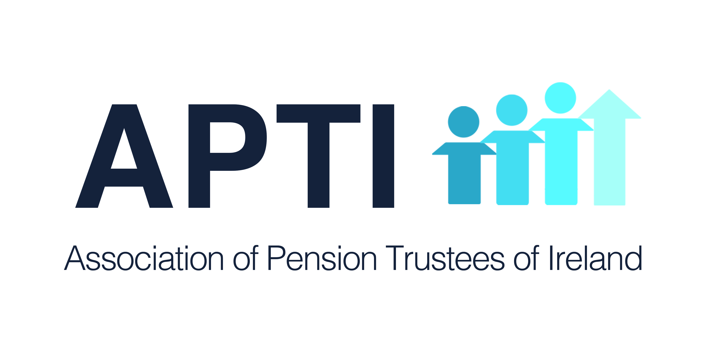
OIREACHTAS REPORT FOR APTI

December 18 - 20, 2018

PENSION ISSUES

Dail

Tuesday, December 18

Written Questions

Pension Contributions Earning Cap

Deputy Thomas Pringle asked the Minister for Finance the estimated amount that would be generated by reducing the earnings cap for pension contributions from €115,000 to €75,000.

Minister for Finance (Deputy Paschal Donohoe): A Revenue Ready Reckoner, providing estimated impacts for potential changes to a wide range of taxes and duties, is available at www.revenue.ie/en/corporate/information-about-revenue/statistics/ready-reckoner/index.aspx. Page 11 presents an estimate of the yield that would arise from reducing the earnings cap for pension contributions in the manner outlined. According to this data, the estimated yield that would be generated by reducing the earnings cap for pensions contributions to €75,000 would be €85m in a full year. I would also note that reducing this ceiling would impact only on higher rate tax payers.

Public Sector Pensions

Deputy Paul Kehoe asked the Minister for Public Expenditure and Reform if a public sector employee with a break in service has the option of retaining the original pension terms; and if he will make a statement on the matter.

Minister for Public Expenditure and Reform (Deputy Paschal Donohoe): Section 10 of the Public Service Pensions (Single Scheme and Other Provisions) Act 2012 provides that where a person commences pensionable public service after 1 January 2013, they shall be entered into the Single Scheme. Membership of the Single Scheme also applies to former pensionable public servants returning to pensionable public service employment after a break of more than 26 weeks. That being the legislated position, any person meeting such criteria must be entered into the Single Scheme.

Public Sector Retirement

Deputy Michael McGrath asked the Minister for Public Expenditure and Reform the situation regarding public service employees who are on or about to participate in the interim arrangements of a fixed one-year contract and may have wished to avail of the proposed extension to 70 years of age but for whom the Public Service Superannuation (Age of Retirement) Bill 2018 may have come too late; if consideration will be given to accommodating them under the terms of the Bill; and if he will make a statement on the matter.

Deputy Michael Healy-Rae asked the Minister for Public Expenditure and Reform the timeframe for mandatory retirement in the public service (details supplied); and if he will make a statement on the matter.

Minister for Public Expenditure and Reform (Deputy Paschal Donohoe): An amendment to the Bill, proposed by Deputy Barry Cowen, was accepted at Committee Stage on 11 December. The effect of the amendment is require a report to be prepared within 3 months of the passing of the Bill which looks at the group of public servants who reached the age of 65 between 6 December 2017 and the commencement of the Bill and on potential remedies to assist that cohort of workers. Subject to its successful passage through both Houses of the Oireachtas, the Bill will then be presented to the President for signature.

Coillte Pension Scheme

Deputy Michael Lowry asked the Minister for Agriculture, Food and the Marine if a new pension scheme for workers of companies (details supplied) that was agreed with management and unions of the Coillte-owned facility earlier in 2018 will be finalised; and if he will make a statement on the matter.

Minister for Agriculture, Food and the Marine (Deputy Michael Creed): Coillte are required, under Section 44 of the Forestry Act 1988, to submit schemes for the granting of pensions, gratuities and other allowances on resignation, retirement or death in respect of members of its staff, to me for approval with the concurrence of the Minister for Public Expenditure and Reform. I can confirm that a draft pension scheme for employees of the first named facility was accordingly submitted. This is currently under consideration after which I expect a consent request will be finalised in early 2019, subject to the scheme proposal being in order.

Wednesday, December 19

Written Questions

Auto-Enrolment

Deputy Willie O'Dea asked the Minister for Employment Affairs and Social Protection the status of her plans to introduce an auto-enrolment pension system; the expected date the system will come into operation; and if she will make a statement on the matter.

Deputy John Brady asked the Minister for Employment Affairs and Social Protection the stage plans are at to publish definite proposals regarding the new auto-enrolment pension scheme following on from the consultation process that was to feed into the decision making process; and if she will make a statement on the matter.

Minister for Employment Affairs and Social Protection (Deputy Regina Doherty): Pension reform is a Government priority. The ‘Roadmap for Pensions Reform 2018-2023', which I launched in February this year, details specific time-lined actions Government will take to reform our pension system. This includes the introduction, from 2022, of an ‘Automatic Enrolment’ retirement savings system, for those without personal retirement savings. This project timeframe reflects the scale of such a programme and its importance as being the most fundamental reform of the Irish supplementary pension system in generations.

A new ‘Automatic Enrolment Programme Management Office’ within my Department has started the work required to establish the evidence base which will inform future Government decisions regarding the design of the system. An InterDepartmental Programme Board has also been established to provide strategic direction. In August, I launched a national consultation process and a ‘Strawman Proposal for Automatic Enrolment’. This is intended to help the Government in relation to the operational structure and design decisions that will need to be made. The Strawman is a high level draft intended to generate and prompt discussion and improve ideas and should not, in any way, be construed as a confirmation of what form AE will ultimately take. More than 100 submissions were received by the November 4 closing date from employer and employee representative organisations, industry bodies, advocacy groups and interested individuals. My officials have met with many of these groups. I also chaired a number of public consultation seminars held in Dublin, Galway and Cork. In addition, officials have provided a dedicated briefing session for members of the Oireachtas and also attended a special meeting of the Oireachtas Committee on Social Protection to discuss Automatic Enrolment.

It is my intention that the Government will continue to engage with all interested parties throughout the design and development process to ensure that the first members would be enrolled in the new system in 2022.

Semi-State DB Schemes

Deputy John Curran asked the Minister for Employment Affairs and Social
Protection her plans to introduce or amend legislation to enable representation and arbitration for members of semi-State DB schemes; and if she will make a statement on the matter.

Minister for Employment Affairs and Social Protection (Deputy Regina Doherty):
Measures were introduced in 2015 to facilitate engagement between the trustees of a pension scheme and groups representing the interests of pensioner and deferred scheme members. Changes to guidance issued by the Pensions Authority require the trustees of a pension scheme to notify groups representing the interest of scheme members of proposals to issue a direction under Section 50 of the Pensions Act to restructure scheme benefits. This affords the representative group an opportunity to make a submission to the trustees of a pension scheme in relation to proposals to restructure scheme benefits. These changes facilitate engagement between groups representing the interests of pensioner and deferred scheme members and the Pension Authority and the trustees of a pension scheme.
Groups representing the interests of pensioners and deferred scheme members have a right to appeal a Section 50 direction by the Pensions Authority to the High Court on a point of law. While current legislation does not specifically provide that member trustees must include at least one or more members from each scheme membership cohort, namely, active, deferred and pensioners, it does provide an opportunity for membership from each cohort and such members may avail of the opportunity to become scheme trustees or nominate others to act on their behalf.

The Pensions Authority has the necessary powers under statute to investigate the conduct of a pension scheme should it become aware that a scheme is not in compliance with the provisions of the Pensions Act. Where a pension scheme member is of the view that the scheme is not in compliance, he or she may make a formal complaint to the Pensions Authority.

DB Schemes

Deputy John Brady asked the Minister for Employment Affairs and Social Protection the stage at which the Social Welfare, Pensions and Civil Registration Bill 2017 is; if concerns regarding DB schemes have been resolved; and if she will make a statement on the matter.

Deputy Willie Penrose asked the Minister for Employment Affairs and Social Protection the status of her plans for legislative changes in pension law; when amendments will be tabled to the Social Welfare, Pensions and Civil Registration Bill 2017; the reason for the delay of more than a year; when the Bill will be progressed; and if she will make a statement on the matter.

Minister for Employment Affairs and Social Protection (Deputy Regina Doherty): The General Scheme of the Social Welfare and Pensions Bill 2017 (now the Social Welfare, Pensions and Civil Registration Bill 2017), was published in May 2017 and contained a number of key measures relating to DB pension schemes. It is intended that these measures will act to support existing provisions in the Pensions Act by providing for further protection for scheme members’ benefits and enhancing employer responsibilities for their schemes.

In July 2018, Government approval was obtained to draft additional provisions to be included in the Bill at Committee Stage including provisions relating to DB schemes. In developing these provisions, it is essential to recognise the current pension landscape in Ireland so that a balanced, proportionate approach is developed and that unintended negative consequences do not arise. Under existing pension law, there is no legislative obligation on the employer to make contributions to a scheme. However, the provisions of this Bill will introduce a new regime into the Pensions Act 1990 which, amongst other things, will ensure that an employer cannot “walk away” at short notice from the pension scheme it is supporting by providing a 12 month notification, and will enable the Pensions Authority to make a funding obligation direction specifying payments to be made by a sponsoring employer to the pension scheme where no agreement is reached, within a specified time period, to resolve a funding deficit.

The DB provisions are very technical and involve complex policy issues. In order to achieve a resilient solution, it has been necessary to consult with and obtain numerous legal advices from the Office of the AG on various aspects of this policy. When these matters have been resolved and amendments approved by Government, an early date for Committee Stage will be requested.

State Pension Waiting Times

Deputy Aindrias Moynihan asked the Minister for Employment Affairs and Social Protection the waiting times to process applications for the State Pension (Non-Contributory); and if she will make a statement on the matter.

Minister for Employment Affairs and Social Protection (Deputy Regina Doherty): My Department is committed to ensuring that claims for its pension schemes are processed as expeditiously as possible. However, claims for means-tested payments, in particular, remain a challenge and given their nature can require more detailed engagement with the applicant, thereby lengthening the decision making process. State Pension Non-Contributory (SPNC) is a means tested pension with increasing complexity attached to the processing of applications. These challenges can arise from the background and age of claimants, their possible multiple sources of income and savings which can also include stocks, shares and other assets. In addition, an increasing number of claimants are born outside of Ireland and delays can occur while necessary supporting documentation for the pension application is being sourced either directly from the claimant or social security organisations in other jurisdictions. In some instances, claimants do not provide the full information required at application stage. This can slow down the processing of their claim and may result in the need for a visit by an inspector of the Department and perhaps multiple requests for further information before a final decision can be taken on the application.

The SPNC scheme area has a performance target of 75% of new claims to be awarded within 12 weeks of receipt. I understand from my Department that in November 2018, the average time to award was 9 weeks and 80% of claims were awarded within the target timeframe. I wish to assure the Deputy that prompt processing of claims remains a priority for me and that processing times are kept under constant review.

.
Thursday, December 19
Adjourned

Seanad

Tuesday, December 18
No relevant business

Wednesday, December 19
No relevant business

Thursday, December 20
No relevant business

Oireachtas Committee
No relevant business

______________________________________________
LAHIFFE & ASSOCIATES
Public Affairs & Political Communications
+353 87 256 2166
www.linkedin.com/in/franklahiffe

