LAHIFFE & ASSOCIATES
Public Affairs & Political Communications 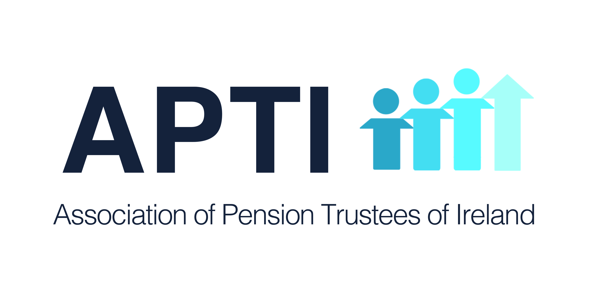
OIREACHTAS REPORT FOR APTI

November 20 - 22, 2018

PENSION ISSUES

Dail

Tuesday, November 20

Written Questions

FSPO

Deputy Michael McGrath asked the Minister for Finance the recourse open to persons in cases in which a decision of the FSPO has not been implemented by the financial services provider; the number of such cases in recent years; and if he will make a statement on the matter.

Minister for Finance (Deputy Paschal Donohoe): In cases where a decision of the FSPO has not been implemented by the relevant financial services provider or pension provider are governed by Section 65 of the FSPO Act 2017. Section 65 (1) states that where a financial service provider or a pension provider fails or refuses to comply with a decision of the FSPO, within the period, or by the date, specified in the decision - the Circuit Court shall, on application to it on that behalf by the FSPO, as he or she sees fit, or the complainant in whose favour the decision was made, make an order.
The FSPO Ombudsman experience to date has been that non-compliance by providers to the terms of an FSPO decision is extremely rare. In the past 5 years, there are less than 5 examples of non-compliance of this nature.

Social Insurance Contributions & Pensions

Deputy Fergus O'Dowd asked the Minister for Employment Affairs and Social Protection if there is a mechanism that can be availed of in a circumstance (details supplied).

Minister for Employment Affairs and Social Protection (Deputy Regina Doherty): The social insurance system is based on the "contribution week". This week begins on the first day of January each year. Each contribution week where a person is engaged in insurable employment a contribution is paid based on the nature of their employment, for most workers earning over €38 per week this contribution will be made at Class A. Only one contribution per week may be used to qualify for a State Pension (Contributory) (SPC). Therefore, in cases where a contributor may have two employments in the same week, only one contribution will count towards the qualifying conditions for SPC. Similarly, a contribution year is made up of 52 contribution weeks and where a person has two or more employments throughout the year the maximum number of contributions that will be reckoned for SPC will be 52, even if there are 104 contributions recorded for the contributor in that year.

One of the main features of the social insurance system is the contributory principle. Employees, along with the self-employed must pay the appropriate number of contributions in order to gain entitlement to any payment, including SPC. Any relaxation to the qualifying conditions for SPC or any other scheme would have a negative impact on the future financial viability of the SIF. Pensioners who do not qualify for the SPC may apply for the means tested State Pension (Non-Contributory).

Pensions for Carers

Deputy Brendan Griffin asked the Minister for Employment Affairs and Social Protection the evidence carers must provide to be considered for the Home Carers Credits under the new TCA calculations for the State Pension (Contributory); and if she will make a statement on the matter.

Minister for Employment Affairs and Social Protection (Deputy Regina Doherty): Legislation is required to underpin the provision of home caring periods in the Social Welfare, Pensions and Registrations Bill 2018 which is currently before the Dáil. Until the legislation is enacted and the supporting regulations required are in place, it is not possible to provide operational details. However, it is the intent to ensure the process of applying for Home Caring Periods is as user friendly as possible. My Department will reuse as much of the information it has on hand as possible, e.g., details about gap periods will not be requested from a pensioner where it is clear from the Department records that they directly coincide with a period for which the person was providing full time care for a child under 12.

Wednesday, November 21

Written Questions

PRSI and ARFs

Deputy Michael McGrath asked the Minister for Employment Affairs and Social Protection the class of PRSI paid by persons under 66 respect of income from an ARF; if such PRSI paid is reckonable for the purposes of the State Pension (Contributory); and if she will make a statement on the matter.

Minister for Employment Affairs and Social Protection (Deputy Regina Doherty): ARFs are funds managed by a Qualifying Fund Manager into which an individual may invest the proceeds of their pension fund when they retire. The income and gains of such funds are exempt from tax within the fund. Any amounts withdrawn from an ARF are referred to as a distribution which is treated as income from an employment. It is subject to income tax and the Fund Manager must operate the PAYE system on it. Under social welfare legislation, any payments received by way of pension are not regarded as reckonable emoluments for the purposes of self-employed PRSI. However, unlike annuity products, ARFs are not pensions but are treated as assets. Distributions from ARFs fall within the charge to Class S self-employed PRSI, or if the recipient of the distribution is a modified class contributor, Class K. Class S contributions may be used to qualify for the State Pension (Contributory). Class K PRSI contributions do not give entitlements to any social insurance benefits.

Thursday, November 22

Finance Bill: Report Stage (edited)

Deputy Michael McGrath: I move amendment No. 41: In page 145, between lines 32 and 33, to insert the following:

“The linking of DIRT rate and Exit Tax rate on life assurance policies
The Minister shall, by the end of 2018, prepare and lay before the Oireachtas a report on the breaking of the link between the rate of DIRT and the rate of Exit Tax from life assurance policies, including the impact of this on life assurance savers.”

The purpose of my tabling this amendment is to try to firm up the answer to the question as to when the Minister expects to deliver the report to which he has committed. To recap very briefly on this issue, it relates to the Exit Tax on certain life assurance products, in particular long-term investment products. Until recent years, the Exit Tax rate was aligned with DIRT. The Minister's predecessor announced a four-year cycle of 2% reductions in DIRT. When the most recent reduction comes into effect in January, DIRT will therefore be down to 35% but the Exit Tax will remain at 41%. In 2020, DIRT will be down to 33%, so the gap will get bigger because Exit Tax will remain at 41%.
There is a policy issue here which we have discussed a number of times in that the differential in the tax treatment of the return from both these products will essentially encourage consumers to put their money into bank-type savings products, on which the return at present is as close to zero as makes no difference. We therefore need to examine the policy implications of this because we want to encourage longer-term saving, longer-term commitment to investment products and so on. The Minister has committed to a report to try to tease out the policy implications. Obviously, there are fiscal implications of doing anything, and I think this is why he has not done anything by way of trying to realign the rates. I believe, however, that we need to give some attention to this in a policy context and then in future Budgets to revisit the decisions that have been made.

Minister of State at Department of Finance (Deputy Michael D'Arcy): The report will be made available before the end of this year. It is in draft form at present. Minister Donohoe, just has to read it and then it will be published.

Amendment withdrawn

Seanad
Tuesday, November 20
No relevant business

Wednesday, November 21
No relevant business

Thursday, November 22
No relevant business

Oireachtas Committee
Social Protection Committee
Social Welfare, Pensions and Civil Registration Bill 2018: Committee Stage (edited)

Minister for Social Protection (Deputy Regina Doherty): I move amendment No. 4.

In the ordinary course, a claimant must have paid 520 full rate social insurance contributions, which typically would be class A PRSI contributions in the private sector or class S if one was self-employed, in order to qualify for the Contributory State Pension. However, the Social Welfare Act 2017 provides that claimants who have paid at least 260, but less than 520, full rate social insurance contributions and who have also paid modified rate contributions may be assessed for what is known as a mixed insurance pension. Modified rate social insurance contributions are PRSI contributions at classes B, C and D and typically paid by public servants.
In practical terms, the mixed insurance Contributory State Pension will typically enable people who have worked in both the public sector and the private sector or in self-employment to secure a reduced rate Contributory State Pension to supplement their public sector pension. The amendments I am introducing have been designed to ensure the wider provisions of Section 9 which provide for the introduction of aggregated contribution methods will be extended to pensioners who receive the Contributory State Pension based on mixed insurance records. Consequently, such pensioners will also be in a position to benefit in those instances where they can demonstrate an entitlement to home caring periods.

Amendment agreed to.

______________________________________________
LAHIFFE & ASSOCIATES
Public Affairs & Political Communications
+353 87 256 2166
www.linkedin.com/in/franklahiffe

